# 03. MovieDB

You are given an unresponsive website (**HTML** + **CSS** + images). Your task is to **make the site responsive**.

The site layout should change according to the browser viewport / screen size.

You need to implement 2 layout: **width <= 768px and width <= 414px**. The figures below represent this layout:

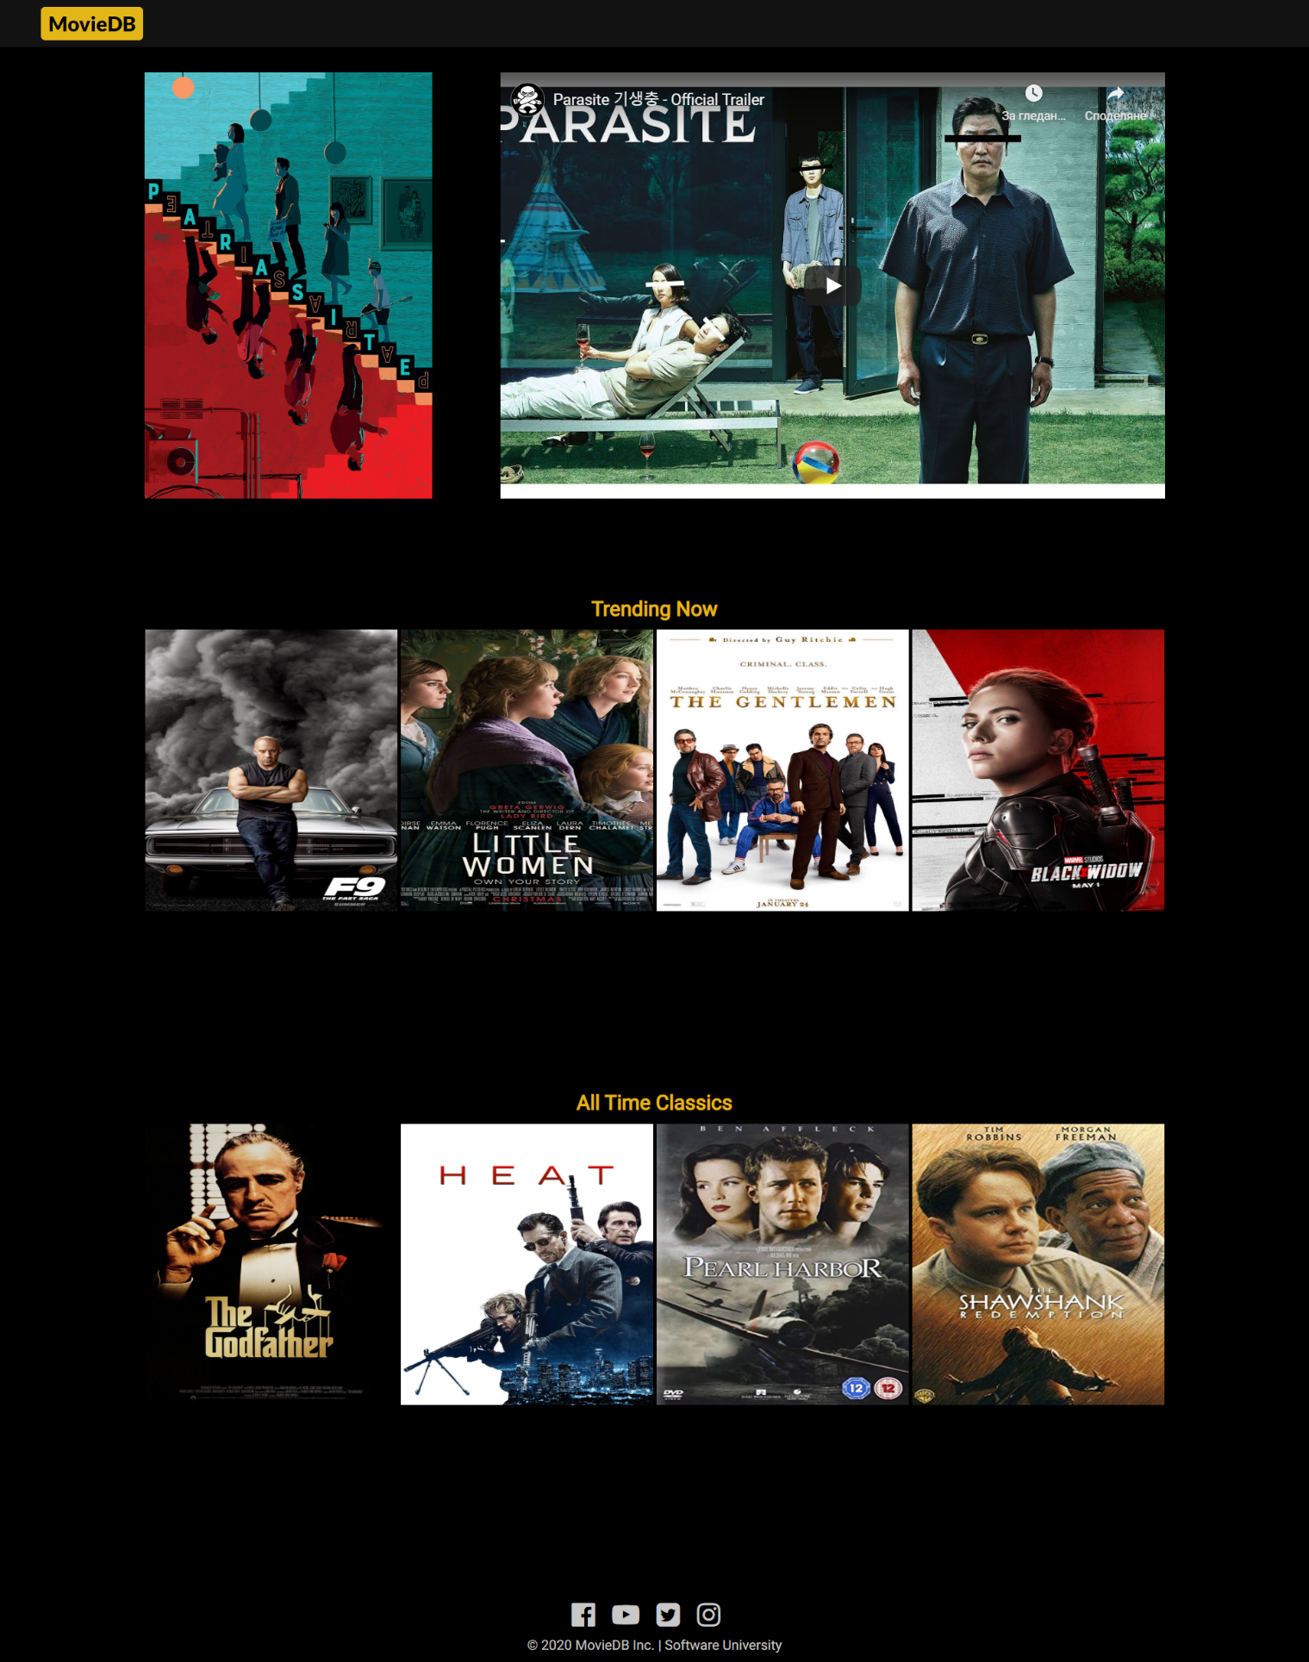

## Output

The output should be valid **HTML5** + **CSS3** + **images** that implement the above responsive site.

## Constraints

* You are **NOT** allowed to change the given **HTML** and **CSS**.
* You should write styles **only** in responsive.css file.
* You are NOT permitted to use libraries like Bootstrap
* The site should open correctly in the latest version of Chrome
* Pixel-perfect implementation is NOT required
* You are **permitted** to modify **ONLY** the **responsive.css** file